Task Sheet 2: Words from People

Words sometimes come from the names of famous – or infamous - people. (What is the difference between being famous and infamous?) Words like these are called eponyms.

- The Marquis de Sade was a cruel man who enjoyed inflicting pain. What is the word that comes from his name?
- John McAdam, a Scotsman, invented a process for sealing roads using tar. What is this called on an airport runway?
- Charles Macintosh invented a type of waterproof cloth. What article of clothing is named after him, and where is it called this?
- James Bowie invented a weapon in the American pioneering days. What is it?
- In NZ, we call them gumboots; what are they called in England, and after whom are they named?
- What improvement did Samuel Plimsoll make to the safety of ships?
- Sally Lunn sold these in Bath, England, around 1800. What did she sell?
- During World War II, an engineer, Donald Bailey, designed a temporary, easily-erected construction for use by soldiers that has continued to be useful. What did he design?
- Mata Hari became very famous during World War I? If we call a woman a 'Mata Hari', what has she been doing?  - Thespis was a famous actor in Ancient Greece. What is a modern term for an actor? | 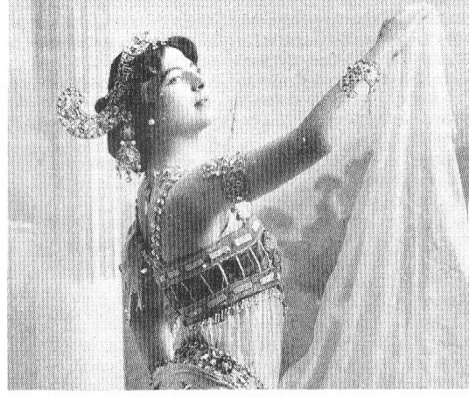
- Give the meaning of each of the following words, and explain after whom it was named.

Begin by copying the example:  chauvinism: absurdly exaggerated patriotism (love of one's country);  male chauvinism: belief in the superiority and privileges of men.  - from Nicholas Chauvin, an absurdly devoted follower of Napoleon, Emperor of France |  |  |  |  | 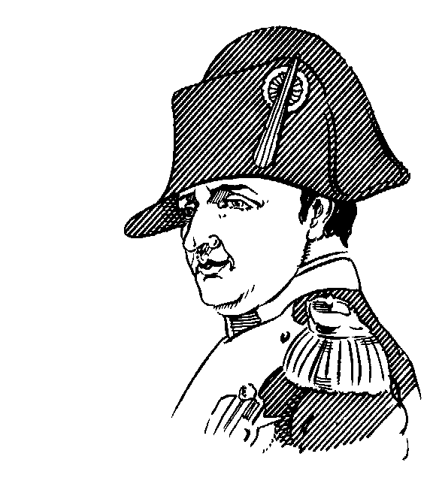
- pavlova  - sandwich  - grog  - a quisling  - a judas |  | - teddy bear  - mesmerise  - boycott  - machiavellian  - platonic | - cardigan  - saxophone  - spoonerism  - dunce  - lynch | - maverick  - bowdlerise  - guillotine  - July  - August
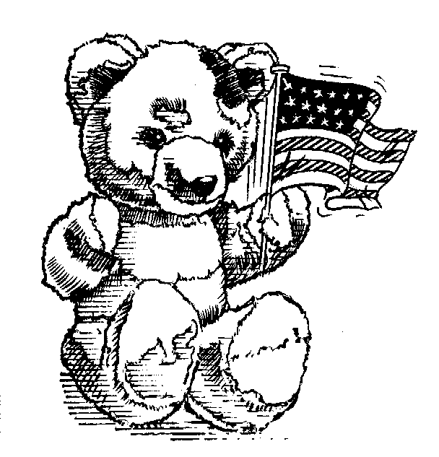 | And:  # gerrymander, Don Juan, Casanova, a bobby, hooligan, a luddite, McCarthyism, masochist, platonic, stonewall, levis, leotards, knickerbockers, Stetson, derrick, biro, frisbee, silhouette, shrapnel, Rolls Royce. . .  food and drink: Benedictine, Garibaldi biscuits, Bloody Mary, Granny Smith, greengage, loganberry, praline, melba toast. . .  dogs: Jack Russell, St Bernard, Dobermann. . .
Middle English

The Normans might have won the Battle of Hastings, but the conquered English won the battle of the languages.
By 1100, O.E. had absorbed so much from Norman French that linguists give it a new name, Middle English, which is spoken in England till about 1500.
By 1350, M.E. has completely replaced French as the language of England. At this time, the first great English poet, Geoffrey Chaucer, wrote The Canterbury Tales, in English rather than in French or Latin.
M.E. is much closer to the English we speak than to O.E. See how easy it is to work out the meaning of this passage written in ME:

Lat tak a cat, and fostre hym wel with milk  And tendre flesh, and make his couch of silk,  And lat hym seen a mous go by the wal,  Anon he will weyveth milk and flessh and al,  And every dayntee that is in the hous  Swich appetite hath he to ete a mous.  foster = feed flesh = meat  swich = such anon = immediately  weyveth = turn away from | A knight ther was, and that a worthy man,  That fro the tyme that he first bigan  Ti ridan out, he loved chivalrie,  Trouth, and honour, freedom and curteisie.  Ful worthy was he in his lordes werrre,  And thereto hade he ridan (no man ferre)  As wel in Cristendom as in hetheness,  And ever honoured for his worthiness.  NB: "his lordes werre" = the war of his lord; in time, this became "his lord's war", the apostrophe indicating the missing 'e' no longer in use.

The Development of Surnames

It was in Chaucer's time that English people first started using surnames. Before that, you would probably have just one name – Egbert or Joan – or possibly be known as 'the son of' someone – Johnson, Thomson, Jobson. Soon this was not enough. Two names were needed, and surnames started to be used.
You might be identified by where you lived:
- Brooks, Rivers, Hill, Dale, Moor, Hall, Street, Wood  - Washington, Lincoln, Cleveland  You might be identified by occupation:  - Abbot, Barber, Bowman, Butcher, Butler (bottle-maker), Carpenter, Cartwright, Constable, Cook, Cooper, Driver, Glover, Harper, Hunter, Mason, Miller, Piper, Porter, Priest, Sadler, Salter, Smith, Thatcher, Waxman, Weaver. Or Palmer, if you had been to the Holy Land. | 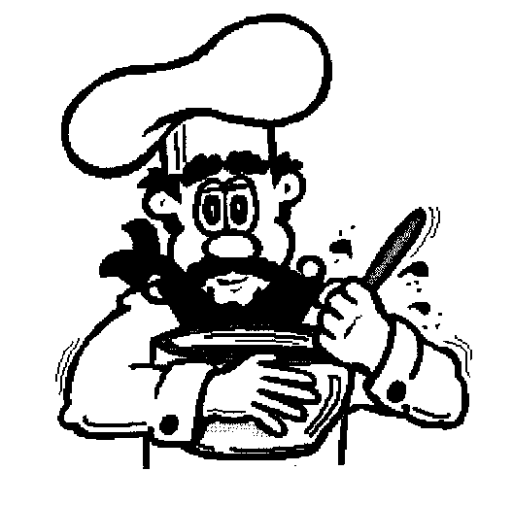
People from abroad were identified from their previous home:
- Fleming, French, Norman, Holland; Parish (from Paris); or just Newman
Nicknames provided some surnames:
- Little, Long, Fox, Brown, Young, Rich
From Wales came
- Evans (a version of Johns), Owens, and Rhys (Reece).
- The Welsh 'Ll' provided both Floyd and Lloyd. Shakespeare's Captain Fluellen (Henry V) was the English version of Llewellyn.
(The word 'Welsh' comes from an Anglo-Saxon word wealas meaning 'foreigners'.)

