Design and Setting

The setting for a film is more than just the place where the events of the plot happen. More than when we read a novel, when we visualise for ourselves what is described, we are affected by the environment we are shown, which indicates instantly whether the setting is naturalistic or fantastic, realistic or imaginary. The way the setting is established, the design and selection of its details, and the way it is filmed, will together create the world and atmosphere of the film.
If you have completed Task Sheet 1, you will already have some notes based on the first few scenes. Add to them by answering the following questions about the film as a whole.
- Which of the above terms – naturalistic or fantastic, realistic or imaginary – best fits this film? Explain.
- When is the film set? Cite evidence.
- Where is the film set? How do we know?
- What is revealed about the society at this time? How is this revealed?
- What mood is created by the setting? Cite specific details.
- How does the way the film is shot and edited contribute to the mood and atmosphere? [See next page for specific questions on lighting.]
- Which specific settings within the wider setting are significant? Note details that make each distinctive.
- What does V's Shadow Gallery tell us about him?
- There are several flashbacks to times that are different from the contemporary one. For each of these, identify the setting and time, and note how each is shown via camera, light etc.

Costumes
- How have costumes been used to enrich and enhance the setting? What effect is created by V's mask?
Be sure your answers include specific details so that you can write a good answer on setting.
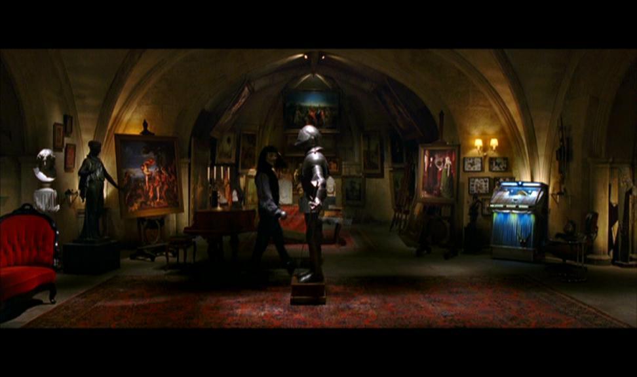
- Read what this very critical writer had to say about the film, and respond to it. You may agree or disagree, but you must give specific examples from the film to support your viewpoint.
But rather than show us a nightmare world in which even the mildest dissent can get you thrown in a cage with a hood over your head, it repeatedly tells us, in lengthy soliloquies, that England's citizens live under constant surveillance, cowering in fear. And yet every time a newscaster lies on the air, he or she is greeted by a hearty cry of "bollocks!" Winston Smith would think he'd died and gone to Disneyland.
As for what's permitted and what's not, it's pretty hard to say. Apparently, in the future, paintings by Vermeer, busts of Nefertiti and Velvet Underground songs covered by Cat Power will be banned, but the middle classes will live in spacious, comfortably appointed apartments. Butter will be scarce, but red spray paint will be readily available to any 9-year-old girl.
It's not that you begrudge Evey's taking the opportunity to advance her career, or even to meet new masked people. It's just that you'd think, you live in a brutality repressive state for most of your life, you look over your shoulder once in a while. Not her. Nor Gordon, who for a high-level media figure at a state-run station comports himself pretty naively. – Carina Chocano, L.A. Times
(Winston Smith is the central character in George Orwell's dystopian novel, 1984.)
[Answers supplied]

