Character Questions

Film director Jim Sheridan says that one of the most important things in any film is what the main character wants. It is the protagonist's desire that drives the story.
Actors are often taught to approach the characters they play by asking themselves, 'What does my character want?'
- Consider each of the main characters in the film from this point of view. What do Thor, Jane, Loki want?

- Each of the main characters has a visual symbol that represents and helps define them.
For each of the main characters, identify the visual symbol.

A well-written character should go on a journey, or trace an arc of development, so that they are not the same at the end of the story as they are at the beginning.
- For each of the three main characters – Thor, Jane and Loki – trace their character arcs, suggesting how they have developed and changed.

- As characters, Thor and Loki are polar opposites at the start of the story. Give details.
Setting it out in two columns would be a good way to demonstrate the differences.
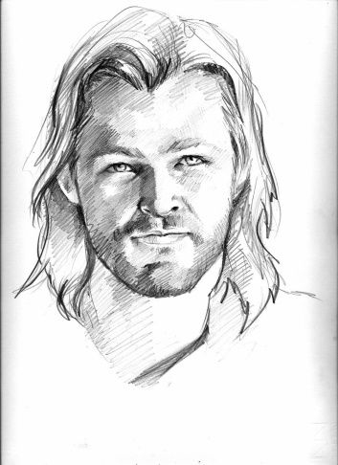
Are they still different at the end? Explain.

- At the beginning Thor is insufferably arrogant and conceited, yet it is hard not to be charmed by him.
How is this achieved?

- Loki becomes Thor’s enemy yet it is hard not to feel some sympathy for his.
How is this achieved?

Respected Rolling Stone film writer Peter Travers wrote, ‘Directed by noted Shakespearean Kenneth Branagh with a class-act grasp of how action works best when it defines character instead of obliterating it…'
- Explain how the action in the movie ‘defines character’.

