Close Reading: Othello's Soliloquy

- Read carefully Othello's soliloquy at the start of V.ii, It is the cause… and answer the following questions.

- There are three possible meanings of the word 'cause' (in both Shakespeare's day and ours): an action which prompts a reaction; a morally justified aim ('all in a good cause'); and a legal accusation in court. Which of these meanings is used here?
- What is the effect of the repetition of the opening clause?
- What word does he use later to reinforce to himself that he is justified in what he is doing?
- Othello makes one statement that is actually quite dishonest. What is it and why is it dishonest?
- What is the real reason Othello is going to kill Desdemona?
- Othello finds himself unable to shed Desdemona's blood. Why is this? What does this tell us about the way he sees her?
- What is the tone of the speech?
- What is the overall effect of this speech on our perception of Othello?
One writer has suggested that the preponderance of images in this speech is because Othello cannot bring himself to face the reality of what he is doing. Instead of confronting the fact that Desdemona is a real woman, he objectifies her with images and symbols in an attempt to idealise his situation.
- Identify the images and symbols that tend to make an abstract object out of Desdemona.
- Contrast is a fundamental technique of this play. How is contrast used here?
- Of the 169 words in this soliloquy, 146 are monosyllables. What is the effect of this? (Clue: speak it aloud.)

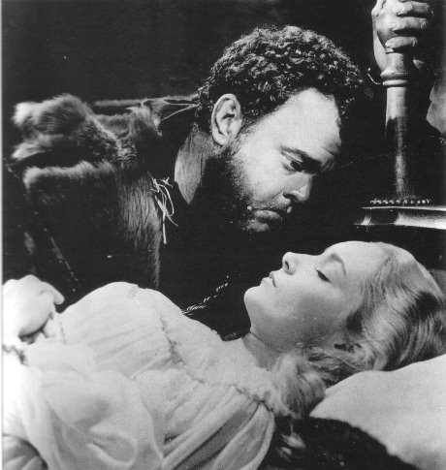
Orson Welles and Suzanne Cloutier

- Discuss: to whom is Othello speaking: himself, the light or the audience?

Answers supplied

