The Middle Ages

The Black Death
The Black Death (or “the Death”) was the name given to the worst disaster ever to hit humankind. The bubonic plague arrived in Europe in October, 1347, when a Genoese fleet docked in Messina, Sicily, and brought the pestilence from Constantinople. Within three years it had spread right across Europe. Estimates of the death toll vary from about two-fifths to three-quarters of the population. It is estimated that about 25 million died. (It reached China 30 or 40 years later, where an estimated 13 million died.) In many places, there were insufficient people spared to bury the dead.
Art for the next 200 years, particularly in Northern Europe, reflects an increasingly macabre fascination with death; look for the work of Hieronymous Bosch, Grünewald, Dürer and Bruegel.
The Black Death reached England in June 1348 (the film is set in March, 1348 – a little early), and within 18 months had spread across the country, killing over half the population of Winchester and Bristol, and two thirds of the students at Oxford.
No-one knew what caused the sickness and blamed the anger of God; urban disorder and especially religious hysteria resulted.
In fact, the plague rose in South Russia or Central Asia, and was spread by fleas travelling on rats; urban squalor and filthy undrained streets hastened its spread. Its main symptom was swollen inflamed lymph nodes (buboes), which appeared under the armpit, as well as fever, vomiting and headache. It was almost always fatal.

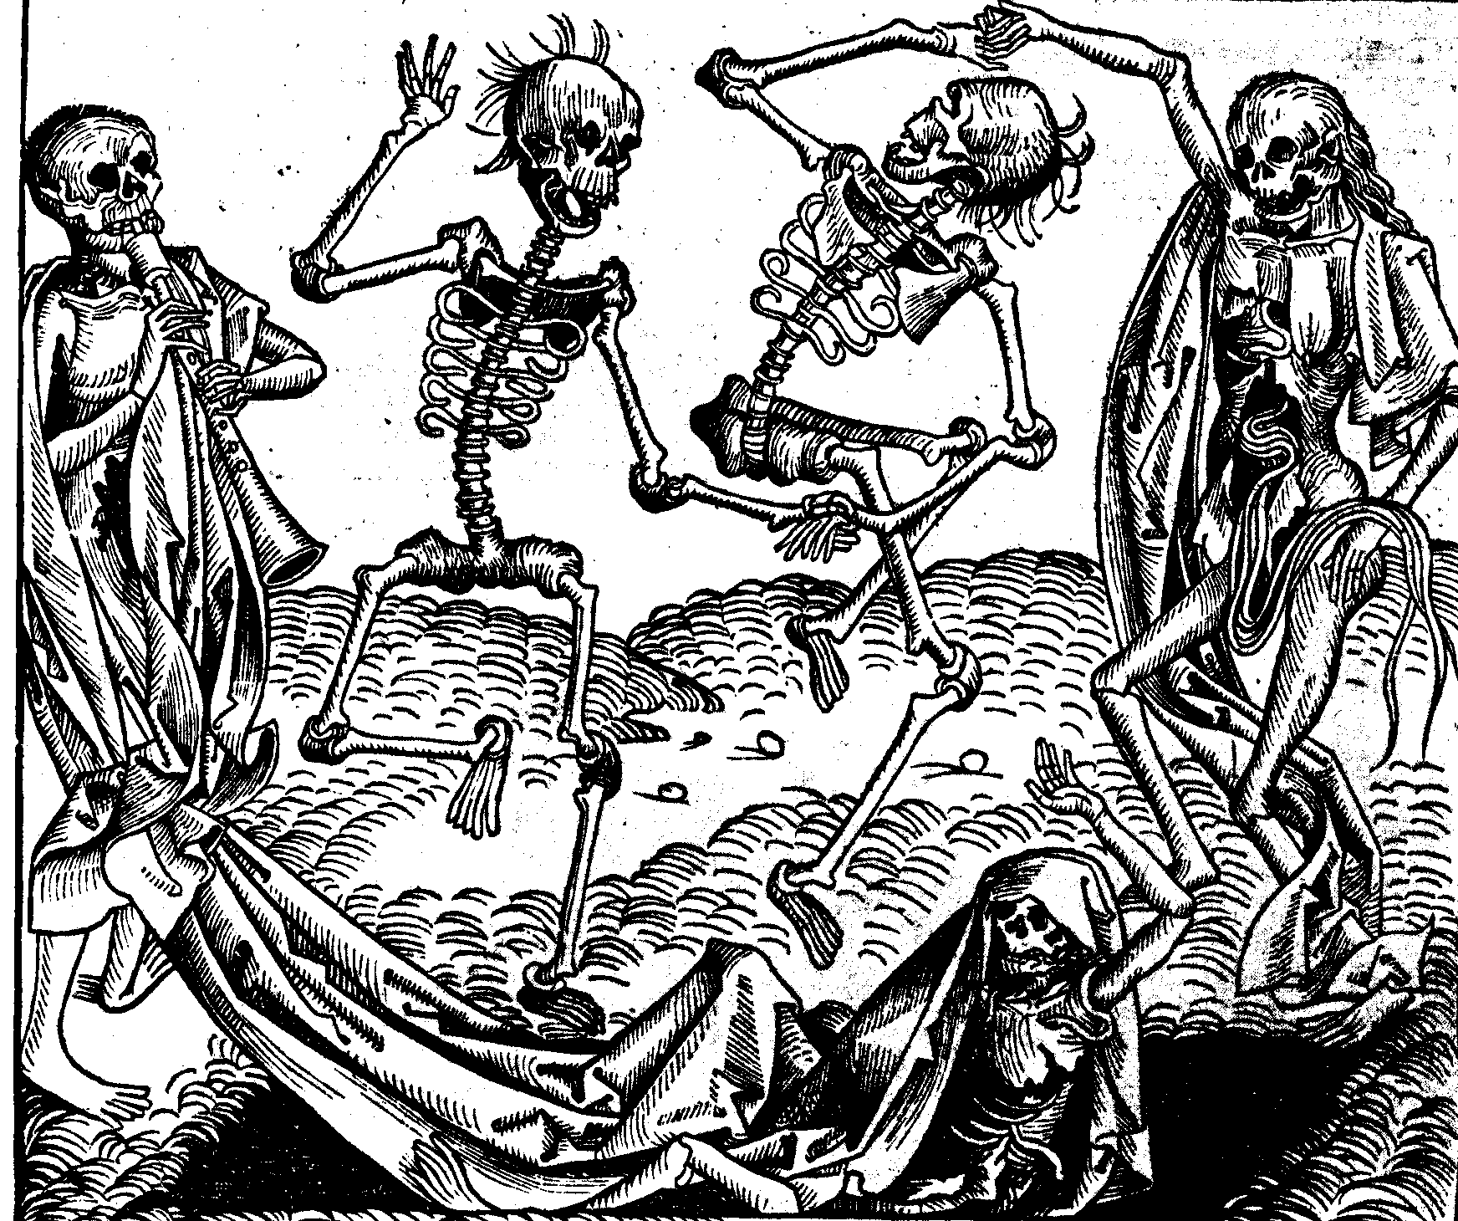

Michael Wolgemut: The Dance of Death.

Understanding These Ideas will Help You Understand the Film
- medieval people rarely travelled beyond their villages.
- life expectancy was very short. (Remember what Searle says happened to his family.)
- Plague and illness were seen as God's punishment for wrongdoing.
- "There's signs within dreams," says Linnet in the film; medieval people believed this very strongly.
- The spire of a cathedral was the tallest building in a city - the top was as close to heaven (i.e. God) as people could go – and was built as high as possible to show faith. The late medieval period – the Gothic (1100-1400) – was a period of great building.

