Structure 2: Patterns

More important than any formal structure are the patterns of action and character in the play.
- Many scenes are balanced or paralleled with a similar scene. For example, there is a dance at the masked ball, during which there is great confusion; the play finishes with a dance which symbolises the restoration of social order.
How many other pairs and parallels can you identify? Comment on the differences between them.
- The characters are in balanced groups of twos and threes. Give details.
- There are many plots and schemes in the play. List them, and explain the effect each one has.
- There are many instances of eavesdropping. List them.
- On seven occasions, characters disguise themselves as someone else. Identify them.
- Nearly every character consciously or unconsciously acts a part, plays a role. How many examples can you identify?
- Deception is used for both good and evil. List the various deceptions under two headings – good and bad.
- Characters in this world tend to judge by appearances. How many examples can you identify? Is there any character who demonstrates the opposite? Be specific.
- "There is some strange misprision in the princes." When given the choice of deciding what is true and what is not, nearly every character makes the wrong choice. 'Misprision', mistaking, misconceptions are frequent.
How many examples can you identify?
- There are many examples of proxy – people performing services on behalf of other people. This is all part of the 'second' hand' nature of much that happens.
How many examples can you identify?

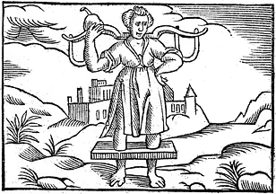
"In time the savage bull doth bear the yoke" – a 1612 woodcut showing a man in a yoke

The proverbial line claims that even the person most resistant to Love's arrow will eventually succumb and bear the yoke of matrimony. Don Pedro predicts that the misogamistic Benedick will one day be Cupid's victim. Benedick attacks marriage, saying he will never thrust his neck into a yoke.
On the previous page is an image of Cupid's yoking an ox - a "savage bull" bearing a yoke; the presence of Cupid suggesting it is a yoke of love or marriage.

