Symbolism is the use of something that stands for or suggests something else by reason of relationship, association, convention, or accidental resemblance.
- What symbols can you identify in the play?
- the storm is the most important symbol. It echoes Lear’s inner turmoil and mounting madness: it is a physical, turbulent natural reflection of Lear’s internal confusion. At the same time, it embodies the awesome power of nature, which forces the powerless king to recognise his own mortality and human frailty and to develop humility for the first time. It symbolises the political disarray that has engulfed Lear’s Britain.
- Gloucester’s physical blindness symbolises the metaphorical blindness that grips both Gloucester and the play’s other father figure, Lear. Only when Gloucester has lost the use of his eyes and Lear has gone mad (mental blindness) does each see the truth.
- Lear's madness symbolises his alienation from the natural order.
- Clothes signify one's place within the hierarchy. They are part of identity. Poor Tom is naked because he is at the bottom of the social hierarchy, and because Edgar has been deprived of his identity. Tom becomes a visible symbol to Lear of mankind at the level of the beasts. Lear removes his clothes – and thus his identity as king.
- Edgar, helping his father, symbolises human devotion; in combat he symbolises justice triumphing over evil.
- Gloucester's castle represents the 'civilised' world in contrast with the wild elements outside. Lear has identity only within this world; on the heath, he has none. The irony is that the castle is where Cornwall shows that humans can be worse than beasts.
- A crown is the universally recognised symbol of power; Lear hands a coronet Cornwall and Albany for symbolic dividing.
- To Lear, still clinging to the remnants of his world, the 100 knights are his kingdom and symbolise his identity.
- Dover represents safe haven and healing; it also symbolises to Gloucester his escape from the misery of this world through suicide – and ironically his rescue from despair. Lear is similarly rescued and healed in Dover.
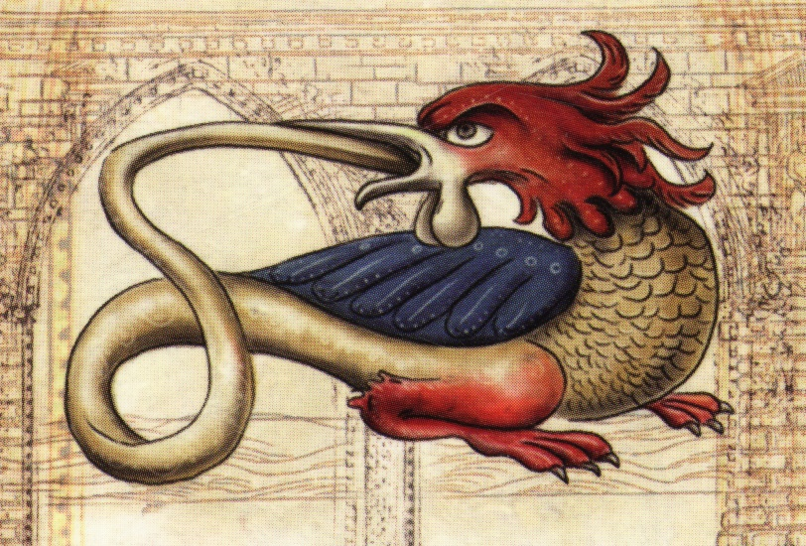The play interpreted as allegory
- Lear: "Come not between the dragon and his wrath". The dragon, which devours his own tail, symbolises the self turned from the outer world and inward on itself. Lear also symbolises anger, wrath.
- Cordelia represents the rational faculty of humankind. She also symbolises patience – the antithesis of anger – and perfect goodness.
- Goneril and Regan represent self-will. When they prevail, rationality is banished and self-will governs.
- Edmund represents appetite, the outer man, cynicism; Kent loyalty and steadfastness; the Fool is awareness.
- On Tarot cards (introduced to Europe in late C14-early C15), the Fool strolls along a road, carrying his belongings on a stick over his shoulder. In Greek mythology Hermes was the god of travellers, whom he guided on their perilous ways, just as the Fool is a companion and guide for Lear.
- In the Tarot, the Fool also represents innocence and unrealised potential. This fits well with the concept that Cordelia and the Fool are two parts of the same idea.
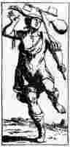 | 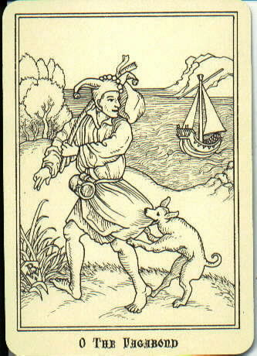 | 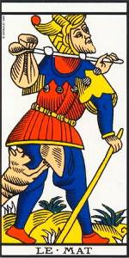
a very early version of the Fool | the vagabond fool | French Tarot Card Fool

Tom himself, naked, savage, bestial, symbolises that revulsion from humanity and the deceptions of human love and human reason which has driven [Lear] into the wild night-storm… [Edgar] has little personality: his function is more purely symbolical. Thus his slaying of the prim courtier Oswald in his guise of a country yokel with broad dialect [IV.vi] suggests the antithesis between the false civilisation and the rough naturalism which are the poles of the Lear universe. So, also, his challenge of Edmund at the end, with the trumpet blast, is strongly allegorical, suggesting a universal judgement. [Wilson Knight, p.184-5]

