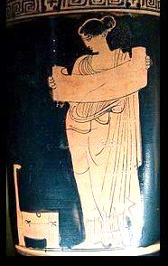 | Guides to teaching films, language and literature  Judy Lewis, MA Hons, Dip Ed, Dip SLT  16 Ritchie Pl, Havelock North 4130, New Zealand  ph. 06 8776-405 or 029 2001 244  artemis.guides@gmail.com www.artemis-film-guides.com

Cost per guide: $75

Postage and packaging:
On CD: $15.00 for up to 3 CDs; add $3 per guide for more than 3
On memory stick: one $15 charge, for any number of guides
Via Internet transfer: no extra charge

Orders made through/to a school can be invoiced.

Private orders
I require pre-payment for private orders (once bitten...), which can be done
by direct crediting my Kiwibank account via Internet banking or over the counter in any Post shop. (Email Artemis for the account number.)

PayPal: Credit card payments can be made via PayPal, though it is better to pay by direct credit.
These NZ prices don't cover the commission PayPal charges, and so there is a $5.00 surcharge per CD or $10.00 for memory stick for NZ PayPal payments. Email Artemis for a direct link if this is your preferred or only option.

Ready now: Get Out
Hidden Figures
Wes Anderson – director study

Feb, 2020

