Production and Post-Production
The shimmering photography, by Seamus McGarvey, brings the heat right off the screen.
Production: Cinematography and Light
- Into which of the lighting schools outlined on the previous page – naturalism or pictorialism – does the lighting of this film belong? Give specific examples to justify your answer.
- What is the effect created by the light in the first part (England, 1935)?
- How does the light change throughout the course of the day in 1935?
- Quote specific examples to illustrate the differences in light and camera techniques in the France section.
- How is the third part (St Thomas's) different again?
- What is the dominant feature of camera use in the coda?
- Summarise – in a table or otherwise – the basic differences between the lighting and camera work in the three parts.
- Lighting is used to particular effect in a number of scenes. Describe three scenes where particularly effective lighting is used.
- Director Joe Wright says that "Light tells the story; light reveals the truth." Quote examples of when light is used for this result.
- Producer Paul Webster said about the filming: "What's especially exciting is that the camera becomes the writer"? Explain what he means.
- What is the purpose of the 5½ minute tracking shot at Bray Dunes? How effective is it in achieving its purpose?
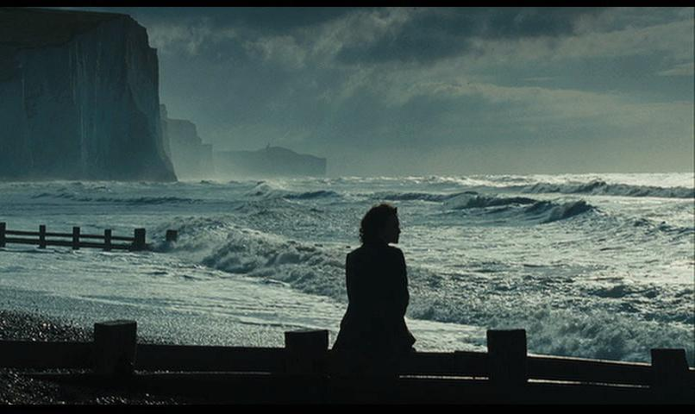

Production and Post-production: Music and Sound
Music and sound effects are usually added to a film in post-production. However Dario Marianelli not only began to work with Joe Wright at the script stage, his music was an intrinsic part of the filming. And unusually, sound effects were incorporated into the music for a seamless effect.
- What is the effect of the typewriter sounds within the music?
- Identify other examples where sound effects merge with the theme music.

[Answers provided in the Teaching Guide]

