Close Reading Task Sheet 4
School
- What does Jenna stop Claire from doing?
- 'I hear words from long ago that were snarled inside me. I'm sorry. So sorry. Words that were trapped inside my head and couldn't be said, frozen behind lips that wouldn't move.' Explain what Jenna means by this.
- Of what is Jenna most afraid?
Ethan
- Jenna says, 'I correct Ethan twice in his evaluation of Walden. I want to be his friend. Friends help friends.' What does she not understand yet?
Allys
- Why is Allys's story important to the novel as a whole?
- What is a 'Restricted Antibiotic Waiver'?
- What does Jenna do that gets her accepted by the others? Why is this ironic?
- What does Gabriel say that echoes Clayton Bender's warning to Jenna?
'Pieces'
- What are 'shards'?
Fine Tuning
- How does the chapter title relate to what happens?
Jenna Fox / Year Fourteen
- What is the difference between the Jenna on the video and the Jenna she is now?
- Quote the words that indicate the 14-year old Jenna had come to terms with how much her parents adored her.
- In what way is Lily like Claire? In what ways are they different?
The New Lily and Jenna
- What time of year is it now?
- Why does Jenna like working at the Mission?
- What is unusual about her and the way she works?
- How is suspense heightened at the end of the chapter?
'Trigger'
- Explain the title of this 'poem'.

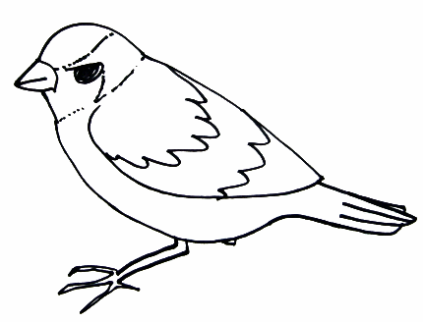

Research
- What is a 'charter' school?
- What is Walden about? Why is it quoted so extensively in this novel?

Discuss: How useful is education when the teachers are other students?

